**Software Flow Diagrams**

Ocean’s 7

ECE Senior Design Lab

# Controls Board Software Flow

# O7 Software (Controls Board).png

|  |  |
| --- | --- |
| Object | Data I/O |
| Inputs | * UART transmission data * Current state |
| Outputs | * Parsed data packet |
| Functionality | Reads and parses received data, updates the State object. Takes state from the State object, sends back to the CPU. |

|  |  |
| --- | --- |
| Object | State |
| Inputs | * Received data (speed/force/etc) * SIGRESET and SIGALLSTOP enabled |
| Outputs | * Data for each controls algorithm * Current state |
| Functionality | Stores the data which best describes what the current state should be, updated by the Data I/O object and used by the controls algorithms. Feeds current state (including state of motor operations) to Data I/O object. |

|  |  |
| --- | --- |
| Object | Reset |
| Inputs | * ADC Interrupt |
| Outputs | * SIG RESET |
| Functionality | On a reset interrupt, calls the signal handler with the SIG RESET flag. |

|  |  |
| --- | --- |
| Object | Motor 1/2 |
| Inputs | * PWM value (integer, 1100-1900) * SIG ALLSTOP |
| Outputs | * None (once the object is updated, the PWM signal is changed. From the software point of view, there is no output, only physical hardware output.) |
| Functionality | PWM instance, handles the PWM signal configuration for motors 1 and 2 (BlueRobotics T100). |

|  |  |
| --- | --- |
| Object | Motor 3/4/5/6 |
| Inputs | * PWM value (integer, 1100-1900) * SIG ALLSTOP |
| Outputs | * None (once the object is updated, the PWM signal is changed. From the software point of view, there is no output, only physical hardware output.) |
| Functionality | PWM instance, handles the PWM signal configuration for motors 3, 4, 5, and 6 (BlueRobotics T100). |

|  |  |
| --- | --- |
| Object | Motor 7/8 |
| Inputs | * PWM value (integer, 1100-1900) * SIG ALLSTOP |
| Outputs | * None (once the object is updated, the PWM signal is changed. From the software point of view, there is no output, only physical hardware output.) |
| Functionality | PWM instance, handles the PWM signal configuration for motors 7 and 8 (VideoRay). |

|  |  |
| --- | --- |
| Process | Sig Handler |
| Inputs | * SIG [RESET, ALLSTOP] |
| Outputs | * SIG [RESET, ALLSTOP] |
| Functionality | Depending on the signal, calls the appropriate method for the various objects that need to be reset/stopped on a received signal. |

|  |  |
| --- | --- |
| Process | Heading |
| Inputs | * Sensor Data (State object) |
| Outputs | * PWM value (integer, 1100-1900) |
| Functionality | Calculates the necessary PWM values for Motor 1/2, which control heading. Based on control algorithms developed in Matlab/Simulink. |

|  |  |
| --- | --- |
| Process | Pitch/Depth |
| Inputs | * Sensor Data (State object) |
| Outputs | * 4 * PWM value (integer, 1100-1900) |
| Functionality | Calculates the necessary PWM values for Motor 3/4/5/6, which control the pitch and depth stability of the vehicle. Based on control algorithms developed in Matlab/Simulink. |

|  |  |
| --- | --- |
| Process | Speed |
| Inputs | * Sensor Data (State object) |
| Outputs | * PWM value (integer, 1100-1900) |
| Functionality | Calculates the necessary PWM values for Motor 7/8, which controls the speed of the vehicle. Based on control algorithms developed in Matlab/Simulink. |

# Teensy 3.6 Software Flow

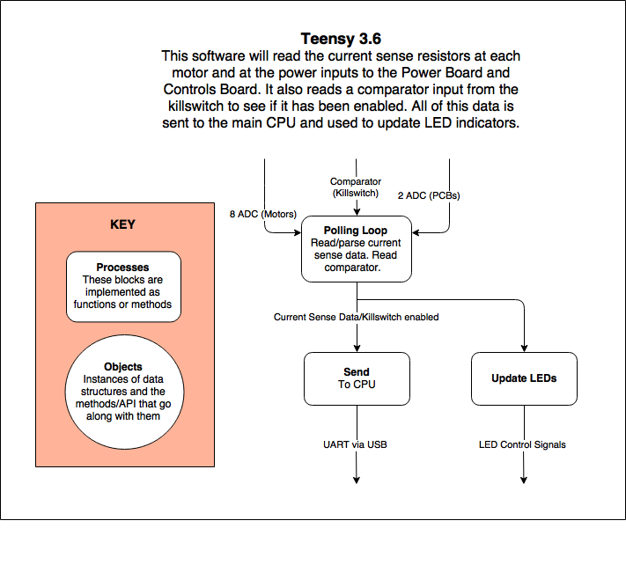

|  |  |
| --- | --- |
| Process | Polling Loop |
| Inputs | * 10 ADCs * Comparator |
| Outputs | * Current sensed [A] * Killswitch Enabled [bool] |
| Functionality | Poll each of 10 ADCs and a comparator. Compile into a packet and send as output. |

|  |  |
| --- | --- |
| Process | Send |
| Inputs | * Data Packet |
| Outputs | * UART signal |
| Functionality | Send the sensed current data and killswitch state to the CPU. |

|  |  |
| --- | --- |
| Process | Update LEDs |
| Inputs | * Data Packet |
| Outputs | * I2C signal |
| Functionality | Parse the current data and send a signal to control the RGB LED array (can be controlled via I2C). |

# Teensy 3.2 Software Flow

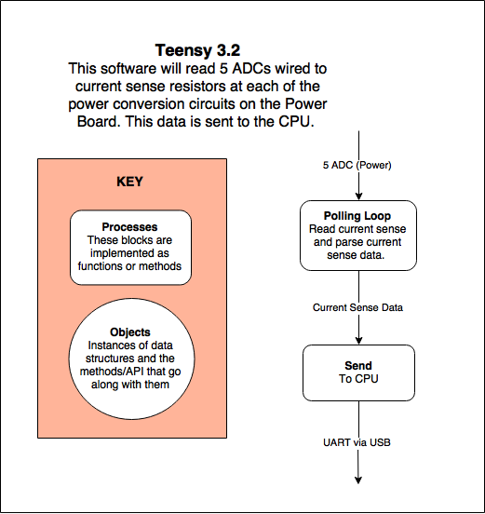

|  |  |
| --- | --- |
| Process | Polling Loop |
| Inputs | * 5 ADCs |
| Outputs | * Current sensed [A] |
| Functionality | Poll 5 ADCs, one for each power conversion circuit current sensor. |

|  |  |
| --- | --- |
| Process | Send |
| Inputs | * Current sensed [A] |
| Outputs | * UART |
| Functionality | Send polled data to the CPU. |